**Title: The ESFRI Clusters at RDA House of Commons**

**Subtitle: Debating commonalities and collaboration for thematic services, training and governance towards the European Open Science Cloud**

**Date: 19 April 2021** (CET) (virtual or hybrid)

**Timeslot**: 3 hours - CET Morning (11.00-14.00 UTC) - 13.00-16.00 CEST

**Goal**

One and a half years after the RDA session in Helsinki, the five ESFRI cluster projects, the RDA community, and European Open Science Cloud (EOSC) representatives come together again, to discuss the past, present and future of their collaboration during the journey of integrating thematic services into EOSC.

We want to beat your Zoom fatigue and engage you in a spiked house-of-commons styled debate. The debate will look at the commonalities and collaboration in the ESFRI clusters, when contributing to the European Open Science Cloud on three pillar topics:

* Thematic **data services,**
* **Connecting to end-user communities**
* **Governance**

For each of these topics, the ESFRI cluster projects will ask for input **from members of the international RDA community**, the ESFRI community, EOSC ecosystem and **data experts and domain researchers** being the end-user community. Input from these stakeholder groups will be collected through their involvement in the debating team and the active audience engagement.

**The ESFRI Clusters at RDA House of Commons Debate. How does it work?**

Each debate topic will have two teams, making their point :

* the **green team** in favor of defending the statement and
* the **red team** arguing against the statement made.

Both teams will map the current situation of **commonalities** of data services, training and governance in the ESFRI cluster projects contributing to the EOSC ecosystem. Participants will discuss the barriers and accelerators for the work ahead and **collaborate in contributing to EOSC**.

You, the audience, will be engaged actively through the statement voting system and opportunities to provide live contributions in the house-of-commons style debate.

**The outputs of the debate**

The debate will be recorded and captured in a joint report, with practical recommendations on **commonalities and collaboration for thematic services, training and governance towards EOSC** to take back to the ESFRI cluster projects and future EOSC projects and initiatives.

**Three topics, three debates**

1. **Debate 1: Thematic data services:** Within the five cluster projects, **ENVRI-FAIR, EOSC-life, ESCAPE, PANOSC and SSHOC** we see different aspirations between infrastructure initiatives prioritising stable general data management services, and the research communities prioritising long-term user-driven data workflows. Obviously, the need for research data services to be findable and usable by projects and users is common to both groups, and in this regard, there is much to be learned from the international research data community. This debate will be driven by **Eva Mendez** (FAIRsFAIR and RDA Europe 4.0 ambassador for interdisciplinary research), with the statement **“Metadata. Everyone thinks it's a great idea, but no-one wants to use someone else's”.**
2. **Debate 2: Onboarding Communities and End-Users**: In the context of EOSC discussions, the ESFRI cluster projects are in an excellent position to represent the interests of the research communities and claim and provide for an EOSC infrastructure that meets the required specificity and flexibility. An important aspect of connecting to communities and the success of EOSC are training, workshops, demonstrations and awareness raising efforts in the research communities. In this discussion we’ll be looking at how the ESFRI clusters can use the existing commonalities to bridge the gaps for collaboration on onboarding communities towards EOSC. We’ll be learning from the best practices in the international RDA community and FAIRsFAIR champions community. The debate will be driven by RDA Secretary General **Hilary Hanahoe**. She will kick the debate off with the statement “**Onboarding the communities and end-users to EOSC still lacks a clear grassroot, bottom-up approach. This puts a timely EOSC in practice at risk.**”
3. **Debate 3: Governance**: Which models for shaping future collaboration and result exploitation have been identified as a suitable vehicle for the consortia involved in the current cluster projects? Which impact will the establishment of EOSC have on the interest from countries in funding European RIs? What are the best practices for formal collaboration with RIs outside of Europe? This debate will be driven by **Franciska de Jong** (director of CLARIN ERIC and member of the EOSC sustainability Working Group). “**In the EOSC governance model, there is no clear link with disciplinary research communities, and in particular with the early career representatives. This undermines the potential for timely alignment with innovative dynamics.**”

Structure of the EOSC Cluster House of Commons

* 10 min: **Welcome to the ESFRI Cluster at RDA House of Commons**

**Debating commonalities and collaboration for thematic services, training and governance towards the European Open Science Cloud** - Ron Dekker, director (CESSDA - SSHOC coordinator - former EOSC Executive Board member) - confirmed

* 5 min: The ESFRI at RDA House of Commons rules - Moderator Martijn van Calmthout
* 40 min: **Debate 1: Data Services**
  + Statement: FAIRsFAIR representative “***Metadata. Everyone thinks it's a great idea, but no-one wants to use someone else's***?” (3 min) - Eva Mendez **- confirmed**
  + Voting by the audience (2 min)
  + Panel, with 2 in favour and 2 against (30 min)
    - Green Team: ARCHIVER/ CERN - Joao Fernandes - confirmed
    - Green Team: EOSC-Life - Carole Goble - confirmed
    - Red Team: ESCAPE - ~~Françoise Genova~~ Mark Allen - confirmed
    - Red Team: SSHOC - Daan Broeder - Confirmed
  + Debate lead defines practical recommendation (5 min) - question to audience to see if they agree/have additional questions.
* 20 min coffee break - with a thematic services matching game (the author & the services, for speed coffee dates) - need for more links with RDA community
* **40 min: Debate 2: Onboarding communities & end-users**
  + Statement: Hilary Hanahoe, Secretary General, Research Data Alliance (RDA) “**Onboarding communities and end-users to EOSC still lacks a clear grassroot, bottom-up approach. This puts a timely EOSC in practice at risk”- confirmed**
  + Voting by the audience (2 min)
  + Panel, with 2 in favour and 2 against (30 min)
    - Green Team: - EOSC Association - Marialuisa Lavitrano
    - Green Team: FAIRsFAIR champion or SSHOC - who? Suzanne Dumouchel?
    - Red Team: ENVRI-FAIR- Ari Asmi - confirmed
    - Red Team: PaNOSC - Rudolf Dimper - confirmed
  + Debate lead defines practical recommendation (5 min)
* **40 min: Debate 3: Governance & closing**
  + Statement: Franciska de Jong, director CLARIN ERIC and member of the EOSC sustainability Working Group. ”***In the EOSC governance model, there is no clear link with disciplinary research communities, and in particular with the early career representatives. This undermines the potential for timely alignment with innovative dynamics*** ” (3 min) **- confirmed**
  + Voting by the audience (2 min)
  + Panel, with 2 in favour and 2 against (30 min)
    - Green team: RDA ECR IG - Fotis Psomopoulos (CERTH, RDA ERC IG co-chair) - confirmed
    - Green team: ESFRI - Mirjam van Daalen - confirmed
    - Red Team: EOSC-Life - Claudia Alén Amaro - confirmed
    - Red team: ENVRI-FAIR- Anca Hienola - confirmed
  + Debate lead defines practical recommendation (5 min)
* Break - 15 min?
* Wrap up - 15 min - visual element?

Who should attend:

* EOSC and research data communities,
* researchers, RIs in EOSC cluster projects,
* ESFRI representatives (including SWG chairs),
* research data experts, research libraries
* RDA working and interest group members,
* EOSC enablers and educators.

## 

## Internal planning information:

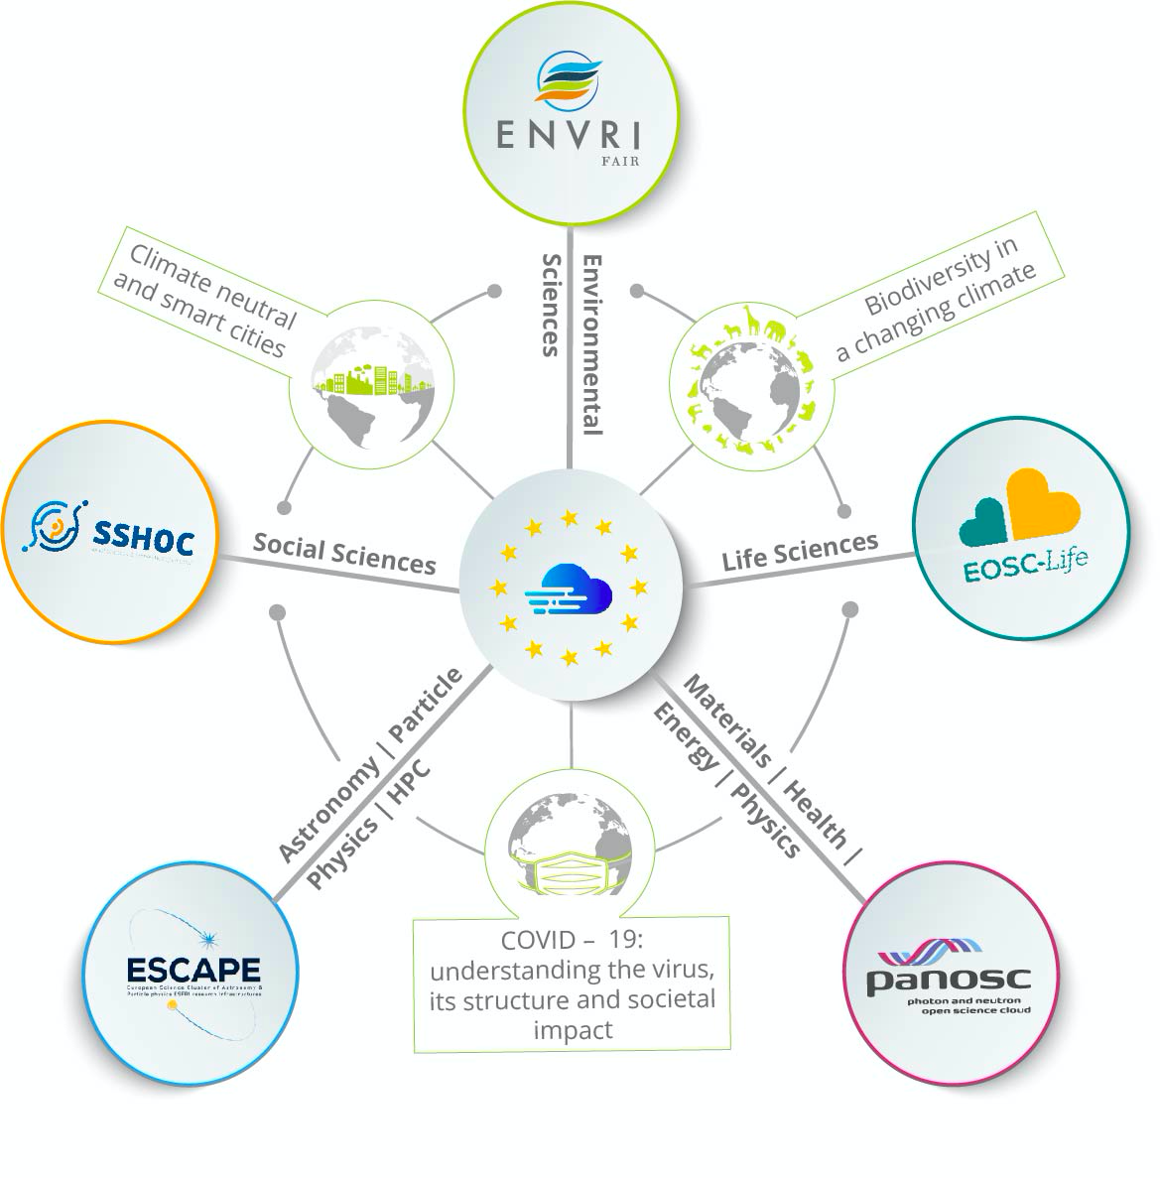

**Draft agenda:**

|  |  |  |
| --- | --- | --- |
| **Time (CEST)** | **Description** | **speaker** |
| 13.00 -13.15 | **Welcome to the ESFRI Cluster at RDA House of Commons**   * Presentation all projects in debate * Presenting Moderator | Ron Dekker, director (CESSDA - SSHOC coordinator - former EOSC Executive Board member) |
| **ESFRI Cluster at RDA House of Commons. Debating commonalities and collaboration for thematic services, training and governance towards the European Open Science Cloud** | Moderator |
| 13.15 -13.55 | **Debate 1: Data services**  Statement: FAIRsFAIR representative “***Metadata. Everyone thinks it's a great idea, but no-one wants to use someone else's***?” (3 min)  Voting by the audience (2 min) | Statement by Eva Mendez (FAIRsFAIR) |
| **Debate (30 min)**: Panel, with 2 in favour and 2 against  **Overview, recommendations** and link back to audience (5 min) | **Moderator**  **Statement maker** Eva Mendez (FAIRsFAIR)  **Debating teams:**   * Green Team: ARCHIVER/ CERN- Joao Fernandes * Green Team: EOSC-Life - Carole Goble * Red Team: ESCAPE - ~~Françoise Genova~~ Mark Allen * Red team: SSHOC - Ron Dekker/Daan Broeder? |
| 13.55 - 14.15 | Coffee break |  |
| 14.15 - 14.55 | **Debate 2: Onboarding communities & end-users**  Statement: RDA and the Communities of Practice (Hilary Hanahoe) Statement: **Onboarding the communities and end-users to EOSC still lacks a clear grassroot, bottom-up approach. This puts a timely EOSC in practice at risk**  Voting by the audience (2 min) | Statement by Hilary Hanahoe (RDA Foundation) |
| **Debate (30 min)**: Panel, with 2 in favour and 2 against  **Overview, recommendations** and link back to audience (5 min) | **Moderator**  **Statement maker** Hilary Hanahoe (RDA Foundation)  **Debating teams:**   * Green Team: FAIRsFAIR champion - Antica Culina * Green Team: SSHOC - Frank Fischer * Red Team: ENVRI-FAIR- Ari Asmi * Red Team: PaNOSC - Rudolf Dimper |
| 14.55 - 15.35 | **Debate 3: Governance**  Statement ”***In the EOSC governance model, there is no clear link with disciplinary research communities, and in particular with the early career representatives. This undermines the potential for timely alignment with innovative dynamics*** ” (3 min) | **Moderator**  Statement by Franciska de Jong (CLARIN ERIC, EOSC sustainability Working Group) |
| **Debate (30 min)**: Panel, with 2 in favour and 2 against  **Overview, recommendations** and link back to audience (5 min) | **Moderator**  **Statement maker**  Franciska de Jong (CLARIN ERIC, EOSC sustainability Working Group)  **Debating teams:**   * Green team: RDA ECR IG - Fotis Psomopoulos (CERTH, RDA ERC IG co-chair) * Green team: ESFRI - Mirjam van Daalen * Red Team: EOSC-Life - who? * Red team: ENVRI-FAIR- Anca Hienola |
| 15.35 - 15.45 | Coffee break |  |
| 15.45 - 16.00 | Wrap up | Moderator |

## Preparation internal meeting 8 April

Participants: Irena, Ana, Martijn, Steph, Marieke

Apologies: Iris

**Recommendations:**

* At the end of every debate a 5-min conclusion is formulated.
* Actors: Martijn + statement makers
* Rapporteurs: note down the mapping (central thesis) + recommendations towards improvements.

**Final recommendations part (Moderator + statement maker):**

* 3 slides with statement & 1-3 recommendations per debate

**Slides for each debate (Trust-IT):**

* 1 with statement
* 1 guiding towards audience voting
* 1 debate team with debaters, affiliations, roles in team (green/red) - statement is title

**Rapporteurs (Ana, Steph, Jana and Iris):**

* Note down the mapping - current status defined in the statement
* Make sure you have the main points
* Templates will be shared
* Prepare your 1 slide as soon as the debate is over
* After debate 3 we have a 10 minute coffee break to align on final conclusions & recommendations

**Content for debate:**

* ACTION Marieke: to send Martijn Position papers clusters.
* ACTION Marieke: ask Ron to send ppt by Thursday 15 April + add slide on RDA P17

**Guidelines & tips debaters:**

* Think about the statement, its current status and direction you want to go?
* Do we have visual elements in Juno for a clear hand-raising?
* We’ll be pinning the videos of all debaters & moderator
* If no visual elements are available in Juno, we’ll ask you to raise your hands

**Practical issues:**

* Juno, do we have a meeting format of webinar/muted format
* Juno, do we have tech support during the session?
* ACTION Marieke: to set in place sli.do
* ACTION Ana & Irena: to set in place rapporteur templates
* Google Suite: ACTION Marieke to set up a specific folder for collaborative working.
* Break out room: ACTION Marieke to liaise with Juno & RDA for a private space
* Coffee breaks: videos of all projects
* Timekeeping: add a visual element in slides, 5 min before the end of the debate.

**During the event:**

* Slides on screen: Marieke
* Modertation & sli.do announcement: Martijn
* Sli.do: Marieke & Iris
* Rapporteurs: **Ana, Steph, Jana, Iris/Vasso**

## Preparation meeting 12 April 13.00-15.00 CEST